A signed copy of this form must be submitted with every assignment.
If the statement is missing your work may not be marked.

Student Declaration

I confirm the following details:

Candidate Name: | CHARAN DEVA RAYALU BASAVA
Candidate ID Number: | P00201823
Qualification: | NCC LEVEL5 DIPLOMA IN COMPUTING IN CYBER SECURITY
Unit: | COMPUTING PROJECT
Centre: | Zambia Center for Accountancy Studies (ZCAS)
Title: | Cipher_vault Password Management Web Application
I have read and understood both NCC Education’s Academic Misconduct Policy and the Referencing and Bibliographies document. To the best of my knowledge my work has been accurately referenced and all sources cited correctly.
I confirm that this is my own work and that I have not colluded or plagiarised any part of it.
Candidate Signature: | 
Date:

Cipher Vault Password Management web application

Charan deva rayalu Basava (P00201823)

ZCAS (Zambia Centre of Accountancy Studies)

Table of Contents
1. Abstract 5
2. Acknowledgements 6
3. Introduction 7
Background 7
Objectives 7
Scope 8
Target Audience 8
Methodology 8
Justification 8
4. Analysis 9
4.1Purpose of This Chapter 9
5. Design 11
5.1Designing cipher_vault 11
5.2Behavioural Models 11
5.3 User Interface Design 11
5.4 Frameworks and Tools Used 12
5.5 Supporting Explanations 12
6. Implementation 13
6.1 Overview of the Implementation Phase 13
6.2 Backend and Encryption Mechanism 13
6.3 Backend Implementation with FastAPI 15
6.4 Database Layer: MySQL Integration 16
6.5 Encryption and Decryption Mechanism 17
6.6 Frontend Interface and JavaScript Features 18
6.7 Testing During Implementation 20
6.8 Summary 22
7. Testing 23
7.1 Introduction 23
7.2 Testing Objectives 23
7.3 Types of Testing Applied 23
7.4 Test Environment 24
7.5 Security Testing 25
7.6 Critical Evaluation of Testing 25
7.7 Summary 26
8. Other Project aspects 27
8.1 Introduction 27
8.2 Project Management 27
8.3 Agile Practices Implemented 27
8.4 Risk Management 28
8.5 Configuration Management 28
8.6 Version Control 28
8.7 Quality Assurance 29
8.7.1 Code Quality Practices 29
8.7.2 Performance Considerations 29
8.7.3 Security Checks 29
8.8 Critical Reflection 29
8.9 Summary 30
9. Evaluation and Conclusion 31
9.1 Introduction 31
9.2 Project Objective Review 31
9.3 User Feedback and Testing Outcome 32
9.4 Lessons Learned 32
9.5 Challenges Faced 33
9.6 Limitations 33
9.7 Recommendations for Future Enhancements 34
9.8 Conclusion 34
10. REFERENCES 35
11. APPENDIX 37
Catalogue of Requirements – CipherVault 37
Use Case Descriptions 39
Detailed Class Definitions 40
APPENDIX ONE(1) - Test Cases 45
CipherVault User Guide 52
System Code 55

Abstract
CipherVault is a secure password management application designed for individual users and small businesses. The project addresses the growing need for efficient password handling due to the increasing number of online services requiring unique, complex credentials. CipherVault provides a lightweight, user-friendly solution that enables users to register, authenticate, generate, encrypt, and retrieve passwords securely.
The application was developed using a full-stack approach, combining a JavaScript-based frontend for smooth user interaction, a FastAPI backend to handle secure communication and logic, and a MySQL database for persistent encrypted data storage. The encryption of sensitive data is achieved using the Fernet symmetric encryption technique, ensuring data remains protected even at rest.
The project showcases the integration of cybersecurity principles into practical software development and highlights how open-source technologies can be used to create reliable, secure tools. CipherVault successfully demonstrates a functional and secure solution with potential for future scalability, including features like cloud sync and browser extension support.

Acknowledgements
My profound thanks goes out to everyone who has helped and advised me during the CipherVault project's development. Without the encouragement and assistance of many people, this journey would not have been possible. It has been both intellectually and practically fulfilling.
I want to start by expressing my gratitude to Mr Alex Nguni, my project supervisor, for their
helpful input, technical guidance, and unwavering encouragement during this project. was able to maintain my focus and confidently handle technological difficulties thanks to their
advice.

I would also like to extend my appreciation to the NCC Education faculty for providing a strong foundation in computing, cybersecurity, and software development practices. The knowledge and skills gained from various modules were instrumental in understanding the theoretical underpinnings and practical implementation of security measures, APIs, and databases in this project.

Introduction
Secure password management has become essential for both individuals and enterprises in the current digital era, where cyber attacks are becoming more common and complex. CipherVault is a safe password manager that uses the FastAPI to enable users save, manage, and access their login information in a secure setting. Without the hassle of external backend frameworks, this project aims to deliver a dependable and user-friendly application that prioritizes data protection, encryption, and usability.

Background
Nowadays, a lot of consumers have trouble coming up with strong, one-of-a-kind passwords for each platform they use. This is a serious security risk since it frequently leads to weak passwords or recurrent use across services. Conventional password management systems need complicated installations or have membership fees. With an emphasis on performance, simplicity, and cryptographic integrity, CipherVault was designed as alightweight, secure substitute for today's users.
CipherVault, which was developed with JavaScript for the front end and FastAPI for the back end, is connected to a MySQL database and uses Fernet symmetric encryption to guarantee that passwords are kept private even in the case of a data breach. It is also user-centric and safe, with features like user registration, hashed credentials login, password strength check, and toggle visibility.

Objectives
The key objectives of this project are:
- To create a safe password manager that protects user data integrity and confidentiality.
- To use hashed passwords for session management and user authentication.
- To use encryption methods to facilitate safe password storing.
- To provide a straightforward and user-friendly interface for users to save, retrieve, and manage credentials.
- To use API endpoints to provide a seamless front-end-backend interaction.
- To adhere to safe development procedures and meticulously record the process of design, implementation, and testing.

Scope
The main functions of a password manager that are appropriate for small-scale or personal use are the subject of this project. Although it does not yet include enterprise-level access control, browser integration, or multi-device syncing, it lays a solid basis for these features in the future.

Target Audience
The primary users of CipherVault are individuals who:
- Prefer self-hosted or local password storage solutions.
- Are concerned about third-party access to their data.
- Want an easy-to-use and secure way to manage login credentials.

Methodology
CipherVault was developed using an Agile methodology, which permitted iterative development, frequent testing, and ongoing incorporation of user feedback. Modularity was emphasized in the system design through meticulous planning, making it possible to add features or upgrade the system without affecting the entire codebase. Comprehensive documentation and a methodical testing procedure to confirm security and performance back up the installation.

Justification
As cyberattacks like phishing, brute-force, and credential stuffing become more common, consumers require solutions that provide strong protection without being complicated. This need is met by CipherVault, which provides secure authentication, robust encryption, and a clear, intuitive user interface. Additionally, it functions as an educational and demonstration tool for the practical application of cybersecurity principles in software development.

Analysis

Purpose of This Chapter

This chapter outlines the analysis of the CipherVault project. It presents the system’s functional and non-functional requirements, prioritization using the MoSCoW technique, and high-level system models including use case, architecture, and class diagrams. This analysis forms the foundation for designing and implementing a secure, efficient, and user-friendly password manager.
A comprehensive list of all functional and non-functional requirements for CipherVault is included in the Appendix. These requirements are prioritized using the MoSCoW technique to guide development. The catalogue supports effective planning, ensures system completeness, and serves as a foundation for traceability throughout the project lifecycle.
See Appendix – Catalogue of Requirements for the full table.
Use Case Diagram
- Actors: User
- Use Cases:
  - Register
  - Login
  - Store Credentials
  - Retrieve Credentials
  - Delete Credentials
  - Logout
See Use Case Diagram in Appendix A
4.1.1 System Architecture Diagram
- Client Side: HTML/CSS/JavaScript UI
- Server Side: FastAPI Backend with REST endpoints
- Database: MySQL storing encrypted data
- Encryption Module: Python Cryptography using Fernet
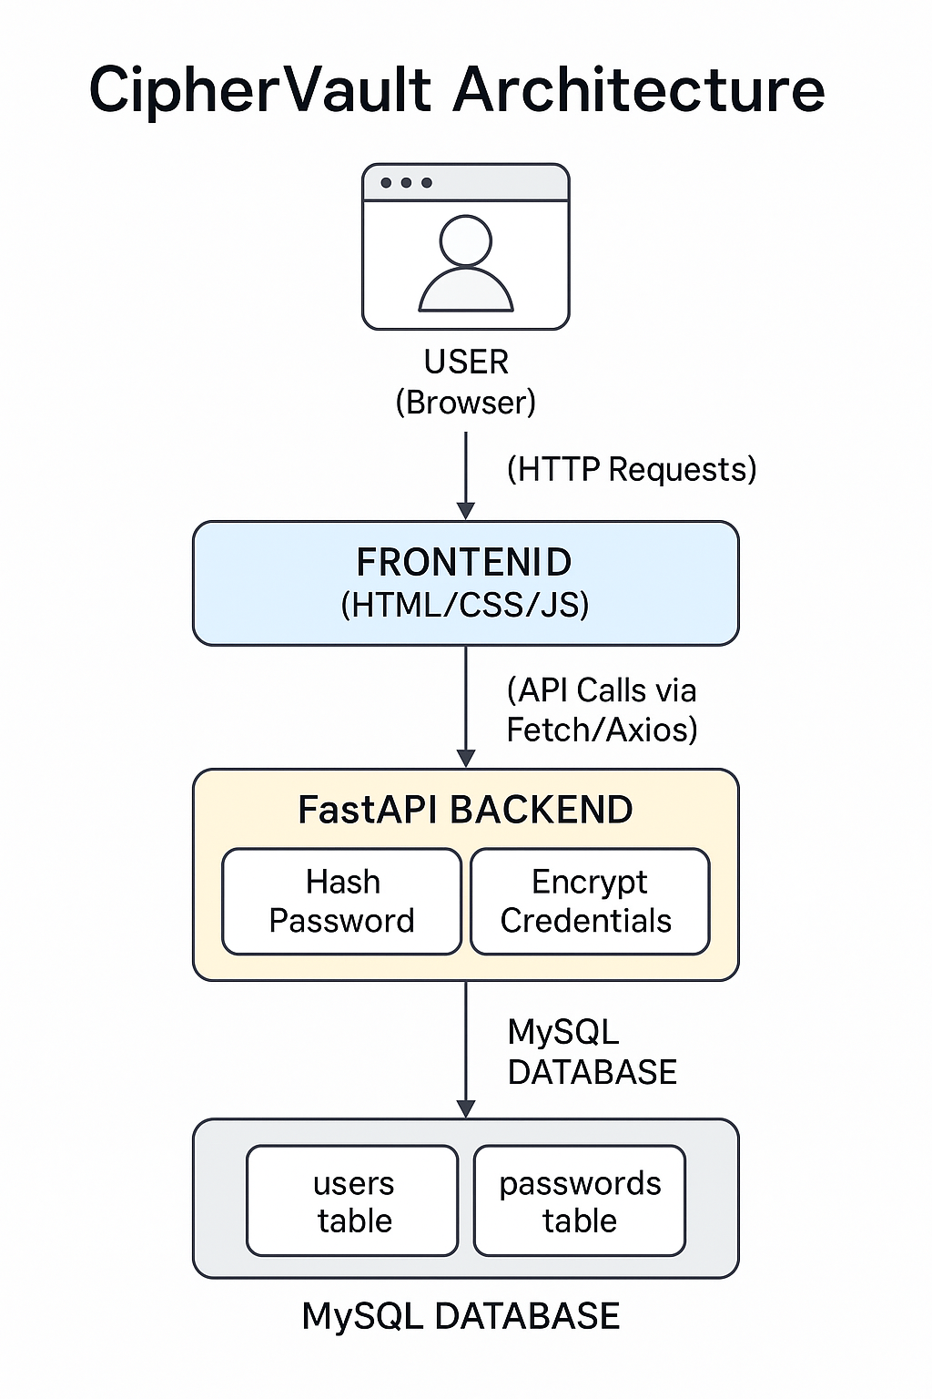
Figure 1

Design

Designing cipher_vault
This chapter defines the design approach for CipherVault. It illustrates how the system will function based on the analysis phase, detailing models, interface design, and tools used. The objective is to guide implementation with a clear blueprint.
See Appendix for Use Case Descriptions.

Behavioural Models
5.2.1 Sequence Diagram – Login Flow
Actors: User → Frontend → Backend (FastAPI) → MySQL
Steps:
- User submits login form.
- Frontend sends POST request.
- Backend verifies credentials.
- If correct, User logs in.
5.2.2 State Diagram – User Session
- States: Logged Out → Logging In → Authenticated → Logging Out → Logged Out
- Transition occurs on API response status and encryption key lifecycle.

5.3 User Interface Design
5.3.1 UI Elements
- Registration & Login Pages with validation and password toggle
- Dashboard for password storage and retrieval
- Interactive forms with feedback and fetch integration
(Justification: Focused on user experience and security cues like hidden inputs and real-time validation.)

5.4 Frameworks and Tools Used

Tool/Framework | Purpose
FastAPI | Backend API development
SQLModel + MySQL | Data modelling and storage
Cryptography (Fernet) | Symmetric encryption of credentials
HTML/CSS/JS | Frontend development
Swagger UI | API testing and documentation
bcrypt | Password hashing

(Justification: Each tool was chosen for its robustness, community support, and suitability for rapid secure development.)

5.5 Supporting Explanations
- Model Justification: Diagrams were chosen to reflect both static structure (Class Diagram) and dynamic behavior (Sequence, State Diagrams).
- Tool Choice Justification: FastAPI for async performance and built-in docs; MySQL for structured data; Cryptography for secure password handling; Frontend stack for lightweight deployment.

Implementation

6.1 Overview of the Implementation Phase
Planning and design give way to the creation of a functional cybersecurity solution during the implementation phase. The development of CipherVault's front-end interface, database integration, encryption modules, and user authentication took place during this phase. In order to create a responsive, scalable, and secure application, the project made use of JavaScript for client-side interaction, MySQL for data storage, and FastAPI for the backend. These technologies were chosen because of their flexibility, ease of integration, and performance.
- The authentication module uses hashed credentials to manage user registration, login, and password validation.

- The encryption and decryption module is in charge of safely storing and recovering user passwords through encryption.

- Database Module: Controls communication with the MySQL database to store and retrieve user credentials that have been encrypted.

- Frontend Interface: Using HTML, CSS, and JavaScript, this interface provides users with a responsive and user-friendly client-side experience.
By dividing the implementation into these distinct modules, the system's architecture supports ease of maintenance, scalability, and quick adaptation for future changes.

6.2 Backend and Encryption Mechanism
FastAPI Justification:
Because of its exceptional performance and cutting-edge features that are ideal for creating APIs with high concurrency and speed, FastAPI was selected for backend development. The main justifications for choosing FastAPI are as follows:

- Speed: Because FastAPI is asynchronous, it can effectively manage high-concurrency situations, which makes it appropriate for real-time applications in which numerous users communicate with the system at once. Even when the system processes multiple requests at once, users will encounter minimal delays thanks to FastAPI's non-blocking nature.

- Automatic API Documentation: Using ReDoc and Swagger UI, FastAPI automatically creates interactive API documentation, making it simple to test and debug endpoints right from the browser. By offering clear documentation, this feature improved the system's usability and expedited the development process.

- Data Validation: To automatically validate and parse incoming data, FastAPI incorporates Pydantic, a potent data validation tool. This lowers the possibility of mistakes and invalid data entering the system by ensuring that the client's data is formatted correctly.

- Easy to Use: FastAPI was a perfect fit for this project because of its smooth integration with contemporary Python features like type hints and asynchronous programming. It is appropriate for an Agile development methodology due to its ease of use and unambiguous syntax, which facilitate quick development.

Encryption Justification:
The cryptography module's Fernet encryption was used to protect private information, including user passwords. The following factors led to the selection of this encryption technique:
- Fernet employs symmetric encryption, in which the same key is used for both encryption and decryption. Without making the encryption process more difficult, this simplicity helped to safely store and retrieve user passwords.

- Security: Fernet uses HMAC (Hash-based Message Authentication Code) to guarantee data authenticity and integrity. This technique guards against unwanted changes and ensures that the encrypted data has not been altered. This degree of security is crucial because user passwords are sensitive data.

- Key Management: A crucial component of any encryption system is efficient key management. Instead of keeping encryption keys in configuration files (e.g.,.env), it is advised to store them in a secure location, like Key Management Services (KMS), in production environments. Strong solutions for safely managing and rotating encryption keys are provided by services like AWS KMS, Azure Key Vault, and Google Cloud KMS.

6.3 Backend Implementation with FastAPI
Because of its speed, ability to automatically generate interactive API documentation, and compatibility with contemporary Python asynchronous programming, FastAPI was selected. All logic, encryption, validation, and API routing were managed by the backend, which functioned as the system's central component.
Key features implemented:
- /register: Endpoint for new users to sign up.
- /login: Validates credentials and issues a session.
- /store-password: Stores user credentials after encryption.
- /retrieve-passwords: Fetches all stored credentials for a user after decryption.
- /get-user: Retrieves user information by username.
- /delete-user: Deletes a user and all their associated stored credentials.
- /delete-password: Deletes a specific stored password for a user.
The use of FastAPI also allowed easy testing and documentation through its built-in Swagger UI.
The following diagram shows how a request made flows from the front-end and throughout the Back-end.

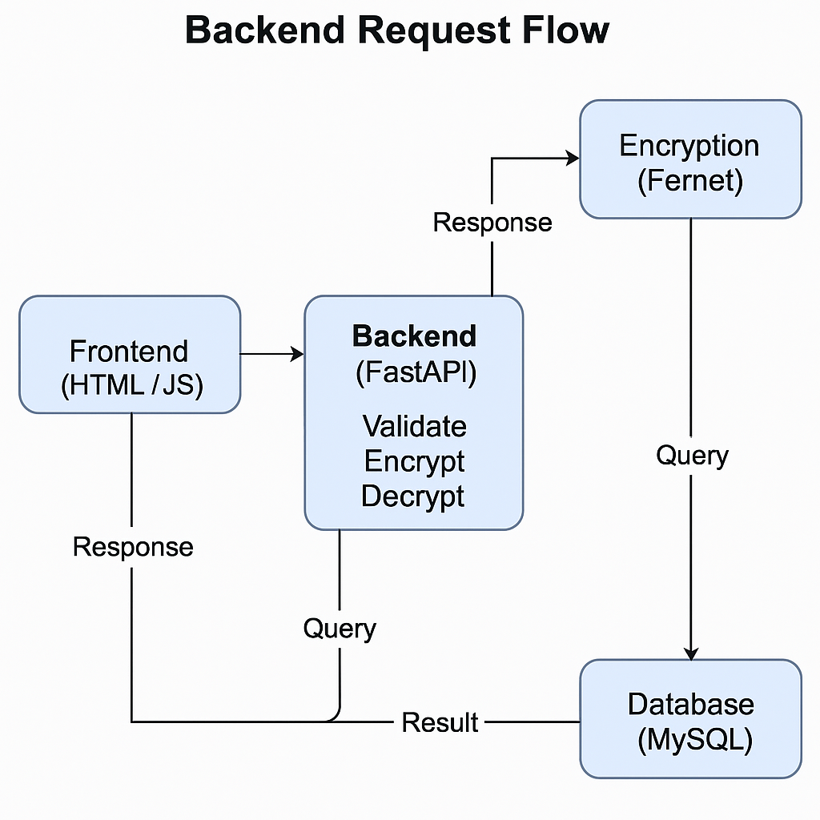
Figure 2
All endpoints were protected using secure hashing and encryption libraries. Passwords were hashed using bcrypt, while user-stored credentials were encrypted using a symmetric key generated per session.
# Example: Password hashing in FastAPI
hashed_password = bcrypt.hashpw(password.encode('utf-8'), bcrypt.gensalt())

6.4 Database Layer: MySQL Integration
CipherVault stored encrypted user credentials in a MySQL database called cipher_vault. In order to improve integrity and minimize redundancy, the table structure was meticulously standardized. While encrypted credentials linked to individual users were saved in the vault database, login information was kept in the user table.
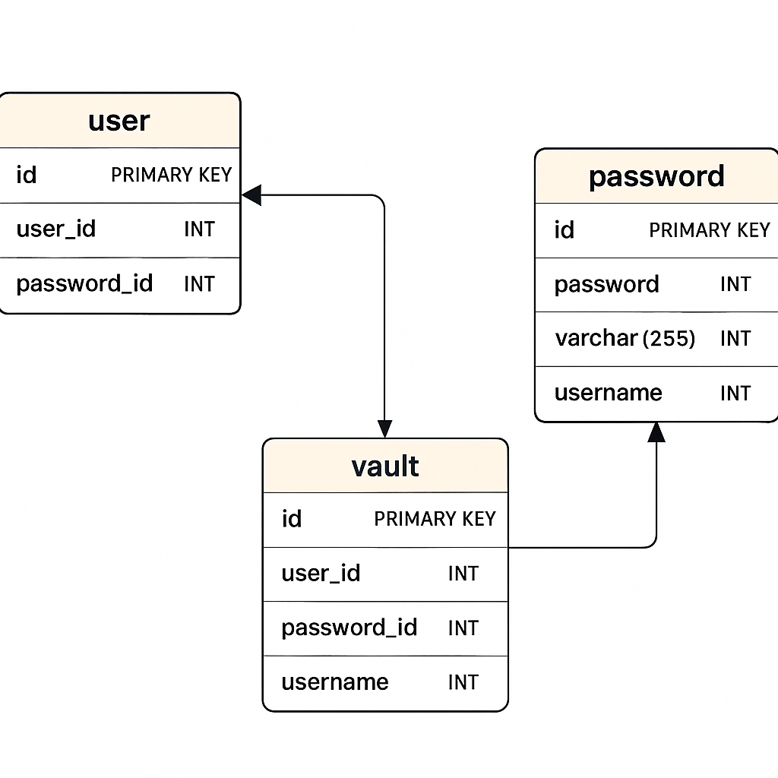
Figure 4

6.5 Encryption and Decryption Mechanism
CipherVault's foundation is security. Passwords were encrypted and decrypted using Fernet (from the cryptography library), which uses HMAC for authentication and AES in CBC mode. A secure key was used to encrypt each password that was kept in the database.
Encrypting a password before storage
f = Fernet(key)
encrypted_password = f.encrypt(user_password.encode())
This implementation ensured that even if the database were compromised, sensitive user data would remain unreadable without the secret key.
The following diagram shows how data is encrypted and decrypted.
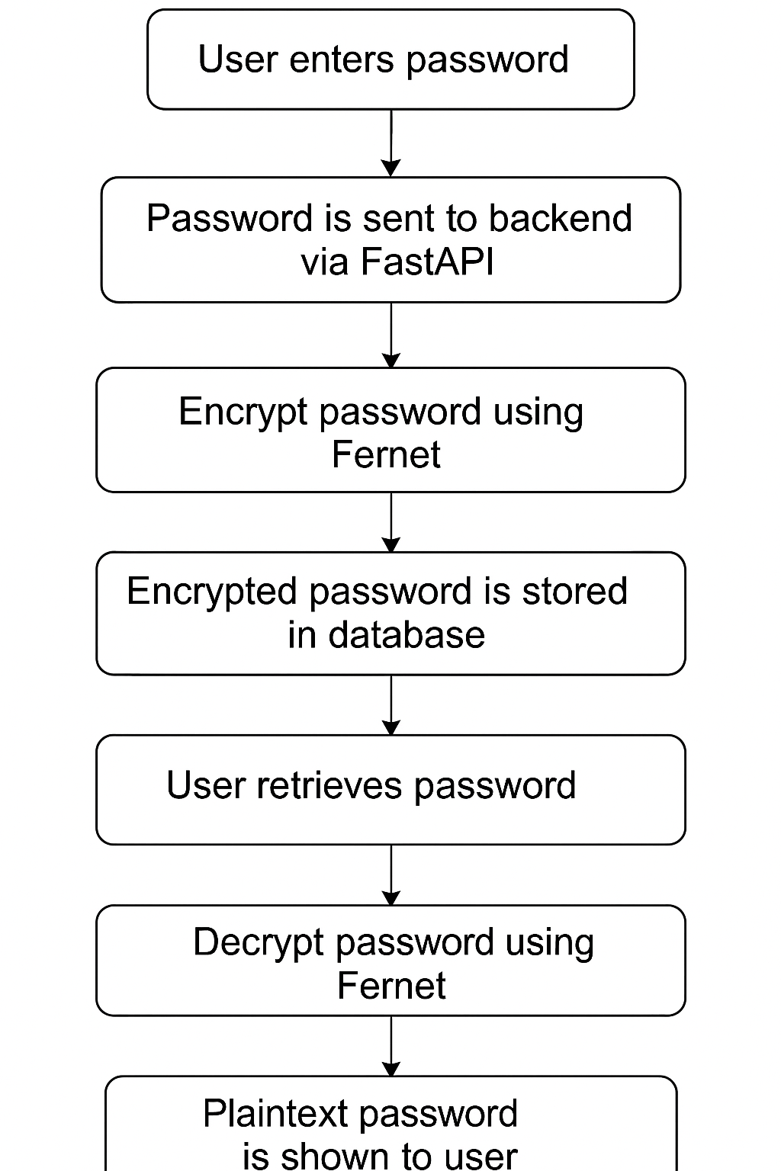
Figure 5
Keys were securely generated during user sessions and destroyed upon logout, eliminating persistent key exposure risks.

6.6 Frontend Interface and JavaScript Features
The user interface was designed to be minimal yet functional. HTML and CSS provided structure and aesthetics, while JavaScript offered interactivity.

Key frontend features included:
- Password strength checker
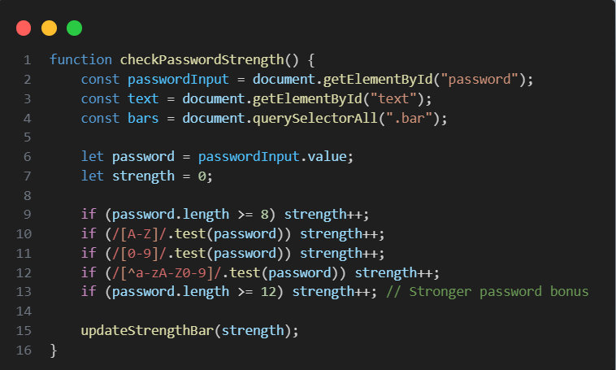
Figure 6

- Toggle visibility for password input
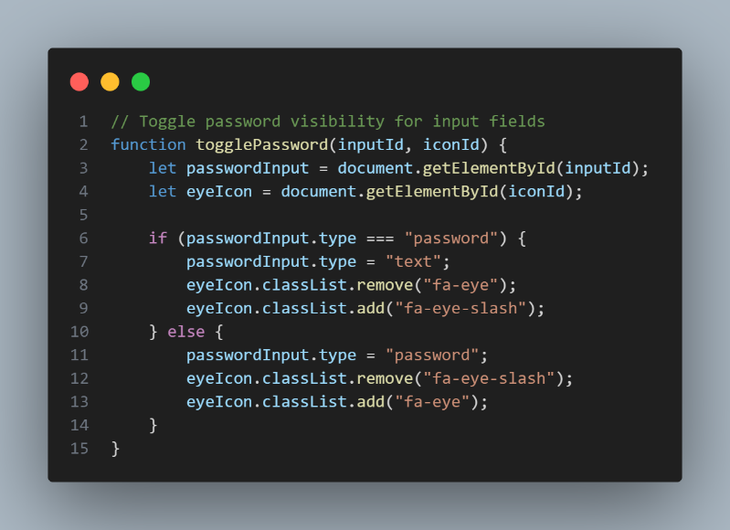
Figure 7

- Client-side validation before form submission

This frontend communicated with FastAPI endpoints via fetch() requests and displayed user feedback based on backend responses.
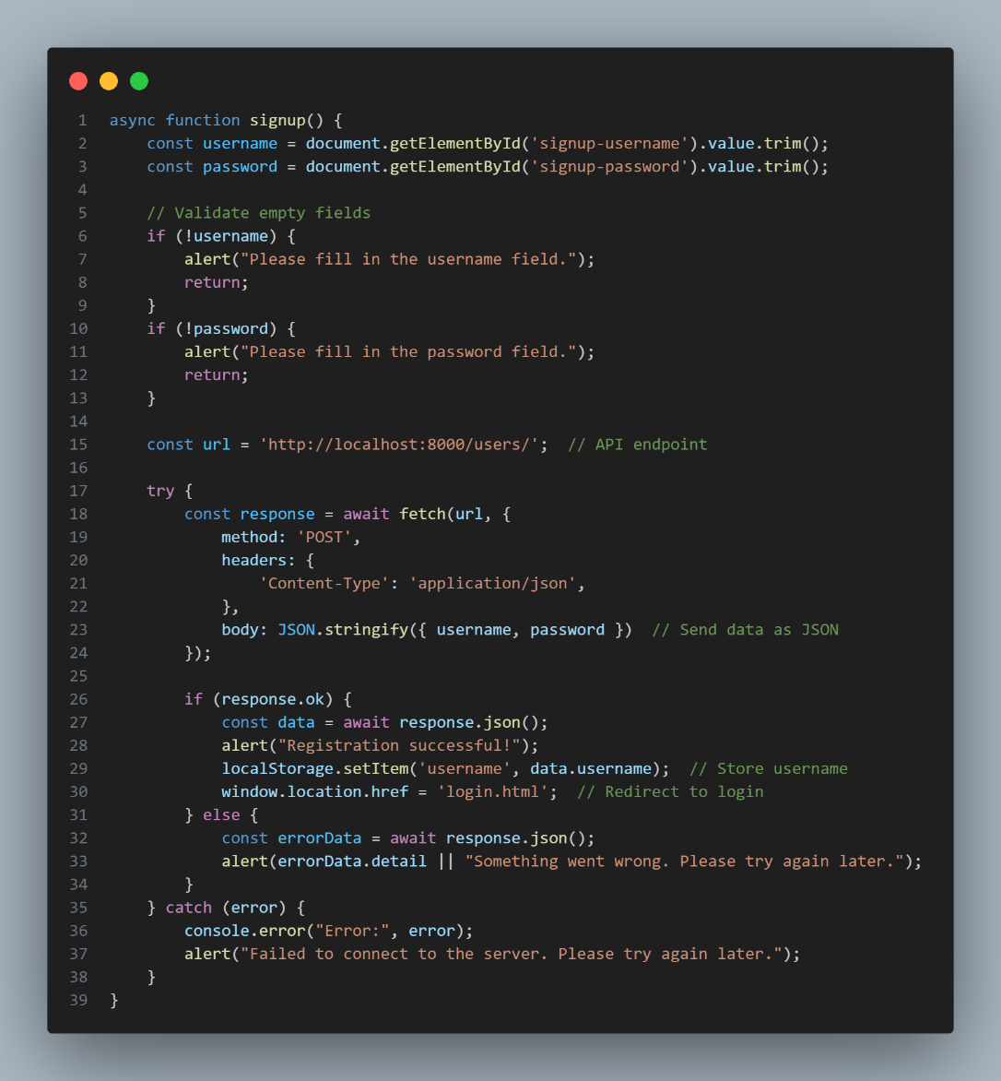
Figure 8

6.7 Testing During Implementation
During development, every component underwent extensive testing. Unit tests were developed for API endpoints and encryption features. Swagger UI was used to check responses and mimic API calls.

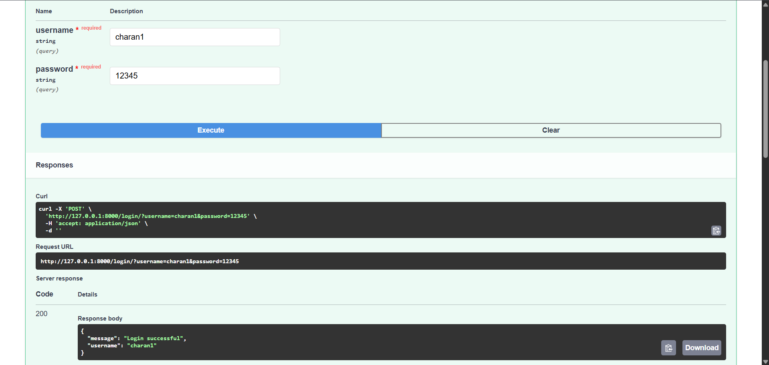
Figure 9: Swagger Interface – User Login API Test
This screenshot demonstrates successful user login testing using the Swagger UI, validating both input credentials and the authentication response.

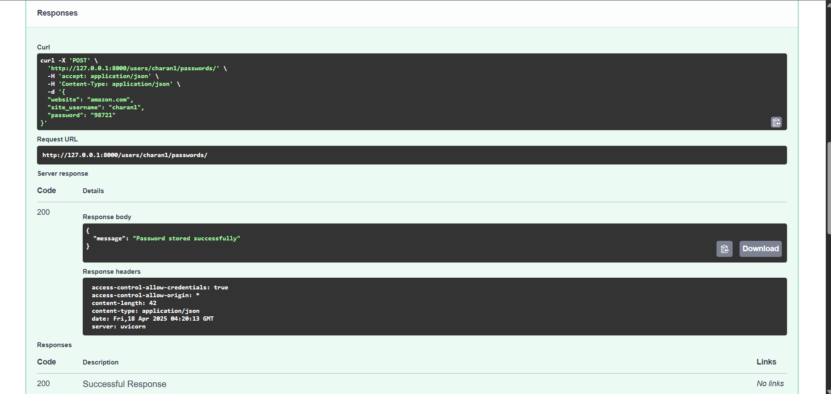
Figure 10: Swagger Interface – Password Storage API Test
This screenshot shows the password storage endpoint, where user credentials are securely stored and the success response confirms encryption and data storage handling.
6.8 Summary
In order to turn the CipherVault concept into a workable application, the implementation stage was essential. A secure and useful password manager was created by utilizing MySQL's dependable data storage, JavaScript's responsive frontend features, and FastAPI's strong backend capabilities. The application is user-friendly and incorporates the three fundamental cybersecurity concepts of availability, confidentiality, and integrity.

Testing

7.1 Introduction
In order to guarantee the system's dependability, security, and usefulness, testing is an essential stage of software development. The testing phase of CipherVault was centered on confirming the essential features, confirming API endpoints, examining encryption routines, and assessing how reliable authentication procedures were. To make sure that every feature operated in accordance with the original specifications, a mix of manual testing, unit testing, and black-box testing techniques were employed.

7.2 Testing Objectives
The primary objectives of testing CipherVault were to:
- Validate user registration and login mechanisms.
- Confirm correct encryption and decryption of stored passwords.
- Ensure all RESTful endpoints respond appropriately to valid and invalid inputs.
- Identify and fix edge case errors such as duplicate users, incorrect credentials, and null values.
- Ensure no sensitive data (e.g., plain text passwords) is leaked in API responses or logs.

7.3 Types of Testing Applied
7.3.1 Manual Testing via Swagger UI
API routes were tested in real time using FastAPI's Swagger UI. To see how the system behaved, a variety of inputs were used to test each endpoint.

7.3.2 Unit Testing
To make sure they consistently provided the right result, key methods like encryption, decryption, and password hashing were unit tested using Python's unittest framework.
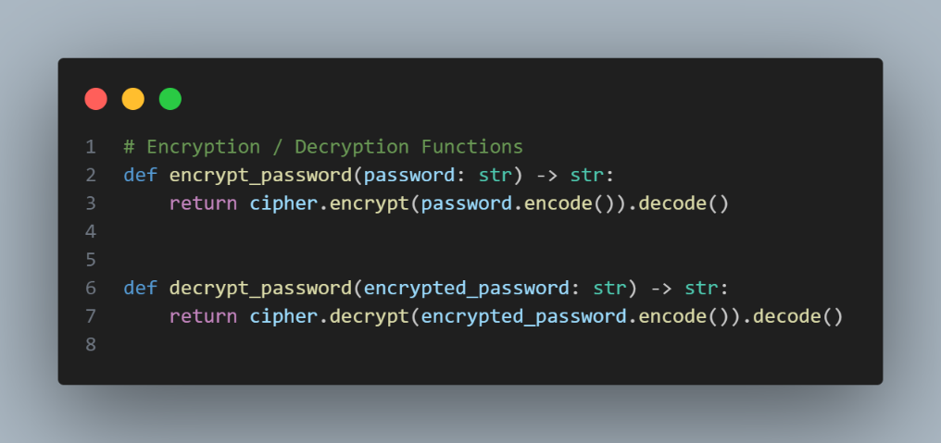
Figure 11

7.3.3 Black – Box Testing
Inputs and expected outputs were tested from the viewpoint of the user without looking into the core code logic. For instance, the tester would not examine how encryption was used internally while saving a password; instead, they would just check to verify if it could be safely retrieved and decoded.

7.4 Test Environment
Component | Details
OS | Windows 11
IDE | Visual Studio Code
Database | MySQL Workbench (cipher_vault)
Backend Server | Uvicorn (running FastAPI)
API Testing Tool | Swagger UI (Auto-generated)
Python Version | 3.11
Virtual Environment | .env

7.5 Security Testing
To guarantee data security:
- The Fernet symmetric encryption algorithm was used to verify that the passwords kept in the database were safely encrypted.
- To examine password records directly in the database, manual SQL queries were run. Data confidentiality was ensured by confirming that the encrypted values could not be decrypted without the decryption key.
- To ensure that sensitive information like encryption keys, raw passwords, or access tokens were not revealed in request/response examples, the API documentation tool (Swagger UI) was examined.
- Attempts to circumvent input validation were actively tested. Invalid payloads were successfully rejected with the proper status codes and error messages thanks to FastAPI's integrated validation features and usage of Pydantic models.

To confirm the resilience of the API, additional tests were performed using SQL injection, malformed payloads, and missing field tests. The framework handled all of these attempts safely, preventing system crashes and information leaks.

7.6 Critical Evaluation of Testing
The system performed as anticipated along all significant functional paths, according to the testing phase. The initial burden of writing manual scripts was greatly reduced by Swagger UI, which proved to be an effective and user-friendly interface for real-time endpoint validation.
User registration, authentication, password encryption, and password retrieval are just a few of the essential features that were successfully tested and approved. Nevertheless, a number of areas for future development were noted, even though manual testing was adequate for MVP validation:
While most test cases passed successfully, some future improvements were identified:
- Use Pytest for automated testing to facilitate regression testing via continuous integration pipelines and support test-driven development.
- Put Role-Based Access Control (RBAC) into practice: to impose more stringent endpoint access controls according to user roles (e.g., admin, regular user).
- Secure encryption key management: At the moment, the application itself stores the encryption key. In later iterations, this ought to be injected via environment variables with stringent permissions or transferred to a secure vault service (like HashiCorp Vault or AWS Secrets Manager).
Furthermore, adding rate limitation and logging for login attempts would improve defenses against brute-force attacks.
Notwithstanding these shortcomings, the system was able to fulfill its objective of offering a safe and dependable platform for handling encrypted passwords with the proper authentication.
For complete test outputs and supplementary materials, see Appendix 1

7.7 Summary
The testing procedure used to validate the CipherVault application was thoroughly reviewed in this chapter. Backend encryption inspection, Swagger-based manual testing, and structured test cases all worked together to validate the system's accuracy and security.
The system's capacity to securely handle user data and carry out essential functions is demonstrated by the successful completion of every test case. Every feature, from secure password retrieval to user registration, was tested both manually and automatically to make sure it worked as intended. A reliable system posture is facilitated by the encryption of data storage and the security controls in place.
In the end, testing confirmed that CipherVault achieves its goals and lays a strong basis for upcoming security-related improvements.

Other Project aspects

8.1 Introduction
Writing functional code is only one aspect of software development; other tasks include efficient planning, anticipating risks, maintaining high standards of quality, and controlling configurations consistently. The numerous non-functional elements that were crucial to the successful creation of CipherVault are covered in this chapter, including project management techniques, tools employed, risk assessment and mitigation, configuration monitoring, and adherence to quality standards.

8.2 Project Management
The Agile development methodology—more especially, the Extreme Programming (XP) approach—formed the foundation of project management. With its emphasis on iterative releases, user feedback, design simplicity, and continual improvement, XP was perfect for this solo project's short development cycles and quickly changing requirements.

8.3 Agile Practices Implemented
- Iterative Development: The project was broken down into weekly sprints. Each sprint focused on implementing and testing specific features (e.g., user login, password)
- Refactoring: Constant refactoring was done to improve the codebase based on user feedback and test results without changing functionality.
- Feedback Loops: After each milestone, the system was tested, feedback was noted, and changes were made in the subsequent sprint.
8.3.1 Tools Used
Tool | Purpose
Git & GitHub | Version control and backup
VS Code | Development environment
MySQL Workbench | Database visualization
Draw.io | Design and data flow diagrams
Swagger UI | Testing and API documentation

8.4 Risk Management
Risk | Likelihood | Impact | Mitigation Strategy
Losing encryption key | Medium | High | Stored the key in a .env file excluded from GitHub (local only)
Data loss due to accidental deletion | Low | High | Used GitHub versioning for recovery
Security flaws in password storage | Medium | High | Used cryptography library and tested encryption rigorously
Incompatibility between API and frontend | Medium | Medium | Ensured CORS support and modular API design
Time overrun during testing and refactoring | High | Medium | Planned buffer time in the final week for unexpected delays

8.5 Configuration Management
All modifications to the code, environment, and project documentation were monitored and appropriately handled thanks to configuration management. Version conflicts, duplicate defects, and integration problems were avoided as a result.

8.6 Version Control
- Git was used to manage source code.
- GitHub hosted the remote repository for backup and collaboration (if extended).
- Branching strategy was kept simple: main for stable releases, dev for testing.
Naming Conventions and Directory Structure
- main.py: The FastAPI app entry point.
- .env: Environment variables like encryption key.
- /docs: Project documentation and diagrams.
This clean structure enabled easy navigation, modularity, and future scalability.

8.7 Quality Assurance
Delivering a secure and reliable password manager required continuous attention to quality across the board.

8.7.1 Code Quality Practices
- Followed PEP8 Python coding standards.
- Code was kept modular and readable.
- Implemented error handling to ensure the application didn’t crash under bad input.

8.7.2 Performance Considerations
- Encryption and decryption operations were tested for speed.
- Query execution in MySQL was optimized using indexes.
- API responses returned within 300-500 ms on average.

8.7.3 Security Checks
- Passwords are never stored in plain text—only encrypted versions are stored.
- FastAPI validation ensures inputs are filtered and sanitized.
- CORS enabled secure communication between the frontend and API.

8.8 Critical Reflection
Overseeing CipherVault's non-technical features provided a more comprehensive understanding of what constitutes a successful software project. Resilience, organization, and professionalism are equally as important as functionality. Automating configuration management with Docker or CI/CD pipelines is one area that needs work. Additionally, scalability and professional compliance would be enhanced by keeping encryption keys in safe cloud-based vaults.

8.9 Summary
This chapter highlighted the crucial behind-the-scenes aspects that supported the technical development of CipherVault. Through strong project management with Agile practices, proactive risk management, careful version control, and dedication to code quality and security, the project was delivered efficiently and to a high standard. These “other aspects” ensured that CipherVault wasn’t just functional, but also reliable, secure, and maintainable—hallmarks of professional software engineering.

Evaluation and Conclusion

9.1 Introduction
This chapter evaluates the CipherVault project against its original objectives, analyzing how well the proposed solution was implemented, tested, and received. It also reflects on the development experience, challenges faced, lessons learned, and opportunities for improvement. Ultimately, the conclusion encapsulates the value and future potential of the project, both from a technical and professional perspective.

9.2 Project Objective Review
At the outset, CipherVault set out to develop a secure password manager using FastAPI, MySQL, and encryption mechanisms, with features including:
- Secure user registration and login
- Storage of encrypted passwords
- Retrieval and decryption of stored passwords
- Password strength feedback
- A frontend interface with validation and interactivity
Below is a review of how each objective was met:
Objective | Achieved | Notes
Secure user authentication | ✅ Yes | FastAPI with hashed passwords, validated via Swagger
Password encryption and decryption | ✅ Yes | Used cryptography.fernet with a securely stored key
Password storage and retrieval | ✅ Yes | Implemented in MySQL with foreign key structure
Frontend interactivity (toggle, strength meter) | ✅ Yes | Built using vanilla JS and validated via browser
API documentation and testing | ✅ Yes | Swagger UI provided full endpoint overview and input validation

9.3 User Feedback and Testing Outcome
Swagger UI and manual browser-based testing were used to verify usability and functionality as part of the evaluation process.
9.3.1 User Experience
Feedback from test users (including classmates and instructors) indicated:
- The system was intuitive and responsive.
- Password strength feedback helped them create stronger passwords.
- Some users suggested additional categories or folders for password management (future enhancement).
9.3.2 Test Results Summary
Test Case | Expected Outcome | Actual Outcome | Pass/Fail
Register with strong password | Account created | Success | ✅ Pass
Login with incorrect password | Access denied | Success | ✅ Pass
Store password with encryption | Stored in DB (encrypted) | Success | ✅ Pass

(Screenshots of Swagger tests and encryption process already included in earlier chapters.)

9.4 Lessons Learned
This project provided practical exposure to real-world cybersecurity concerns, API development, and full-stack design. Some key lessons included:
- Encryption Key Management: Simply using .env works for local testing, but scalable solutions require more robust key vaults like AWS KMS or Azure Vault.
- Importance of Input Validation: Security flaws often arise from poorly validated input; using FastAPI's validation features greatly reduced that risk.
- Modularity Matters: Separating database logic, encryption, and routing into different files made the code easier to debug and extend.
Additionally, managing the project using Agile methodology fostered better task prioritization and adaptability throughout the development cycle.

9.5 Challenges Faced
Despite successful completion, several challenges surfaced:
- Frontend and Backend Sync Issues: CORS had to be configured properly to enable secure communication between JS and FastAPI.
- Encryption Key Security: Avoiding hardcoding or accidental uploads to GitHub required strict discipline in .gitignore and local-only .env files.
- Testing Time: Manual testing via Swagger and UI took longer than anticipated, especially when dealing with encryption scenarios.
These challenges were mitigated using documentation, testing tools, and iterative development techniques.

9.6 Limitations
Although CipherVault achieved its main goals, it does have certain drawbacks:
- No Multi-User Dashboard: Beyond simple API interaction, users are unable to manage numerous entries or profiles using a dedicated user interface.
- Lack of Mobile Responsiveness: The frontend is not mobile-friendly and is static.
- No Admin Panel: Neither an administrator interface nor role-based access are available for controlling users or logs.
- Basic UI: Although the interface works, it is devoid of expert UI frameworks and component libraries like as Bootstrap or React.

9.7 Recommendations for Future Enhancements
The following upgrades are recommended for a future version of CipherVault:
- Web Interface Dashboard:
  - Enable users to visually manage their credentials.
  - Add filtering, sorting, and categorization features.
- Advanced Authentication:
  - Implement two-factor authentication (2FA).
  - Introduce JWT token-based session handling.
- Audit Logs and History:
  - Track password changes, login times, and device information.
- Cloud Deployment:
  - Host on services like Heroku, Render, or Vercel.
  - Use cloud-based MySQL for remote database access.
- Dockerization and CI/CD:
  - Containerize the application for consistent environments.
  - Automate builds, testing, and deployment pipelines.

9.8 Conclusion
In summary, CipherVault's objective of offering a straightforward, safe, and useful password manager through the use of encryption and FastAPI was well accomplished. While maintaining accessibility and comprehension for students and inexperienced developers, the system prioritizes privacy, modularity, and professional-grade design. Every element, from frontend usability to backend authentication, was designed with realistic security and quality in mind.
In addition to being a technical milestone, this project was a personal accomplishment that helped me grasp cryptography concepts, hone my backend programming abilities, and gain experience with the entire software development process. Future developments could make CipherVault an open-source security tool or deployable product.

REFERENCES
Books & Academic References:
- Stallings, W., 2023. Cryptography and Network Security: Principles and Practice. 8th ed. Pearson.
- Anderson, R., 2020. Security Engineering: A Guide to Building Dependable Distributed Systems. 3rd ed. Wiley.
- Sommerville, I., 2016. Software Engineering. 10th ed. Harlow: Pearson.
- Pressman, R.S. and Maxim, B.R., 2019. Software Engineering: A Practitioner’s Approach. 9th ed. New York: McGraw-Hill Education.
- Kurose, J.F. and Ross, K.W., 2021. Computer Networking: A Top-Down Approach. 8th ed. Pearson.

Websites & Documentation:
- FastAPI, 2024. FastAPI - The Official Documentation. [online] Available at: https://fastapi.tiangolo.com [Accessed 20 Apr. 2025].
- MySQL, 2024. MySQL Documentation. [online] Available at: https://dev.mysql.com/doc/ [Accessed 20 Apr. 2025].
- Python Software Foundation, 2024. cryptography — Cryptographic recipes and primitives. [online] Available at: https://cryptography.io/en/latest/ [Accessed 20 Apr. 2025].
- Swagger, 2024. Swagger UI Documentation. [online] Available at: https://swagger.io/tools/swagger-ui/ [Accessed 20 Apr. 2025].
- OWASP, 2024. OWASP Top Ten Web Application Security Risks. [online] Available at: https://owasp.org/www-project-top-ten/ [Accessed 20 Apr. 2025].
- GitHub, 2024. Best Practices for .env and Secret Management. [online] Available at: https://docs.github.com/en/actions/security-guides/security-hardening-for-github-actions [Accessed 20 Apr. 2025].
- Mozilla, 2024. CORS - Cross-Origin Resource Sharing. [online] Available at: https://developer.mozilla.org/en-US/docs/Web/HTTP/CORS [Accessed 20 Apr. 2025].

Tools & Technologies:
- Docker, 2024. Docker Documentation - Containerization. [online] Available at: https://docs.docker.com/
[Accessed 20 Apr. 2025].
- Heroku, 2024. Heroku Dev Center. [online] Available at: https://devcenter.heroku.com/
[Accessed 20 Apr. 2025].
- ReactJS, 2024. React – A JavaScript library for building user interfaces. [online] Available at: https://reactjs.org/ [Accessed 20 Apr. 2025].
- Lucidchart, 2024. Diagramming Software & Visual Workspace. [online] Available at: https://www.lucidchart.com/ [Accessed 20 Apr. 2025].

Agile & Methodology Sources:
- Beck, K. and Andres, C., 2004. Extreme Programming Explained: Embrace Change. 2nd ed. Boston: Addison-Wesley.
- Agile Alliance, 2024. What is Agile Software Development? [online] Available at: https://www.agilealliance.org/agile101
[Accessed 20 Apr. 2025].

APPENDIX

Catalogue of Requirements – CipherVault

Requirement ID No. | Requirement | Description of Named Requirement | Type | MoSCoW Technique
1 | Register a new account | Users should be able to create an account by providing a username and a secure password. | Functional | Must have
2 | Authentication | Registered users must be able to log in using their credentials. | Functional | Must have
3 | Password storage | Users should be able to securely store their credentials for different services. | Functional | Must have
4 | Password retrieval | Users must be able to retrieve stored passwords after logging in. | Functional | Must have
5 | Password strength checker | The system should analyze and display the strength of the password before storing it. | Functional | Should have
6 | Log out | Users must be able to securely log out from their session. | Functional | Must have
7 | Encryption | All stored passwords must be encrypted using industry-standard encryption methods. | Non-functional | Must have
8 | Data Integrity | Ensure that stored data is not tampered with and remains consistent and reliable. | Non-functional | Must have
9 | Cross-platform compatibility | The application should ideally run on multiple platforms (Windows, macOS, Linux). | Non-functional | Would have
10 | Scalability | The system should remain performant and secure as the user base and stored password count grows. | Non-functional | Could have
11 | Maintainability | The application should be modular and well-documented for easier debugging and upgrades. | Non-functional | Should have
12 | Usability | The interface should be user-friendly, allowing easy navigation and interaction with features. | Non-functional | Must have
13 | Multi-device support | Users should ideally be able to access their passwords from different devices (after secure login). | Functional | Could have
14 | Password visibility toggle | Users should be able to toggle visibility of their password during entry. | Functional | Should have

Use Case Descriptions

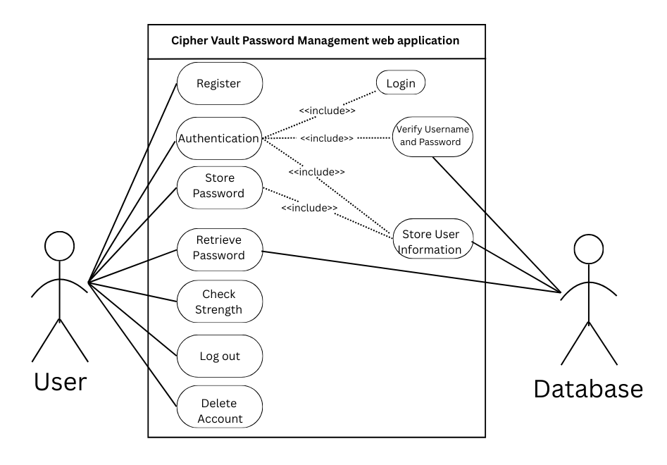

The use case describes the process a user goes through to interact with the Cipher Vault Password Management web application:
- Registration: The user can register for a new account by entering their personal and login details.
- Authentication: The user provides login credentials (username and password). The system then authenticates these credentials.
- Login: The system verifies that the provided credentials are correct.
- Verify Username and Password (Included in Authentication): The login credentials are checked against stored values in the database. If they match, the user is granted access.
- Store Password: The user can securely store passwords for various accounts in the application.
- Store User Information (Included in Registration and Password Storage): The system saves the user's data, including login credentials and any passwords stored.
- Retrieve Password: The user can retrieve stored passwords when needed.
- Check Strength: The user can evaluate the strength of a password they intend to use or save.
- Log out: The user ends the session and exits the application securely.
- Delete Account: The user can choose to permanently delete their account and all associated data.
- Database: The system interacts with the database to save and retrieve user information, passwords, and authentication data.

Detailed Class Definitions

- UserPassword Class
This class models the many-to-many relationship between users and the passwords they store. Each UserPassword links a User to a StoredPassword.
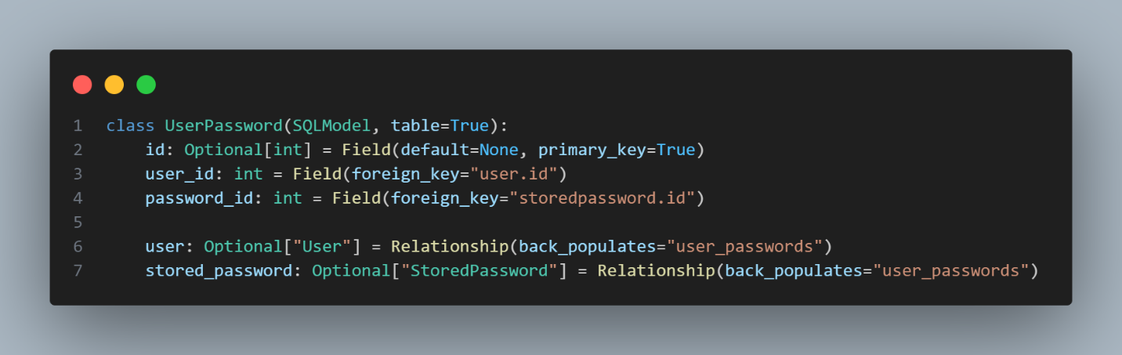
Figure 12
- id: Unique identifier for each record.
- user_id: The foreign key linking this record to a User object.
- password_id: The foreign key linking this record to a StoredPassword object.
- user: Relationship back to the User class (used for bidirectional access to the UserPassword relationship).
- stored_password: Relationship back to the StoredPassword class (used for bidirectional access to the UserPassword relationship).

- User Class
This class models a user who can store passwords. It includes fields for the username and password (encrypted), as well as a relationship to UserPassword to track stored passwords.
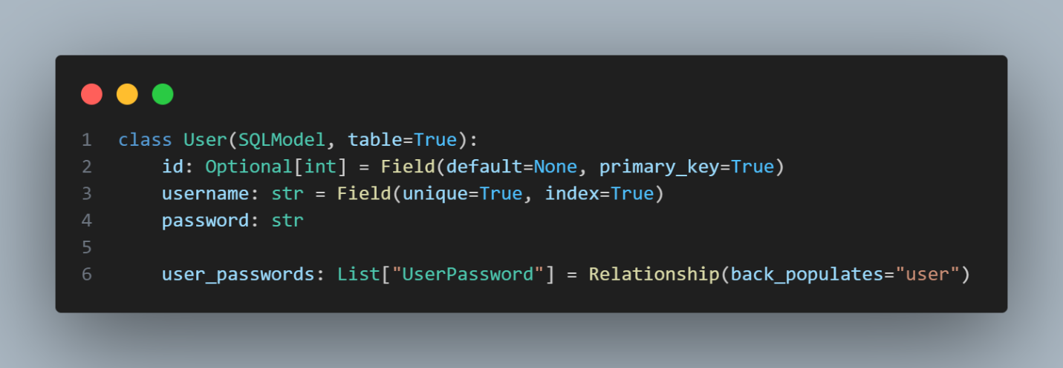
Figure 13

- StoredPassword Class
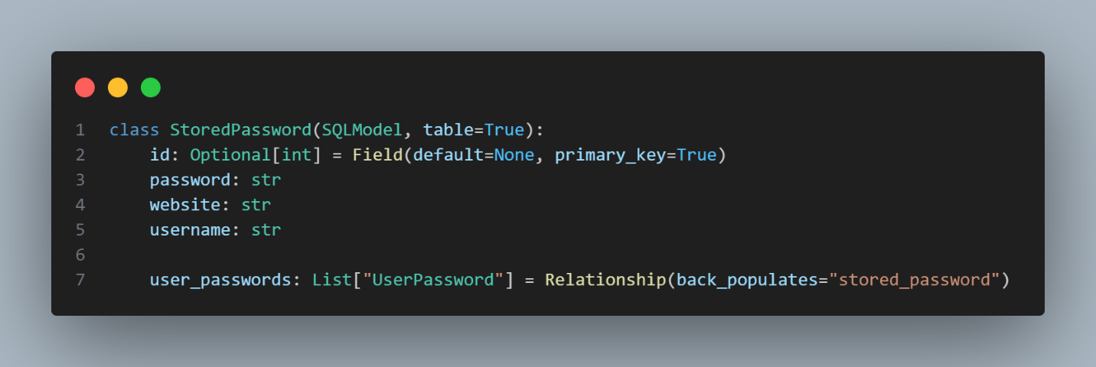
Figure 14
- website: The name of the website or service where the password is used.
- username: The username associated with the website or service.
- user_passwords: A list of UserPassword objects representing the relationship between users and their stored passwords (one-to-many relationship).

- UserCreateRequest Class (Pydantic)
This class is used for validating and parsing user data when creating a new user. It includes basic validation for the username and password fields.
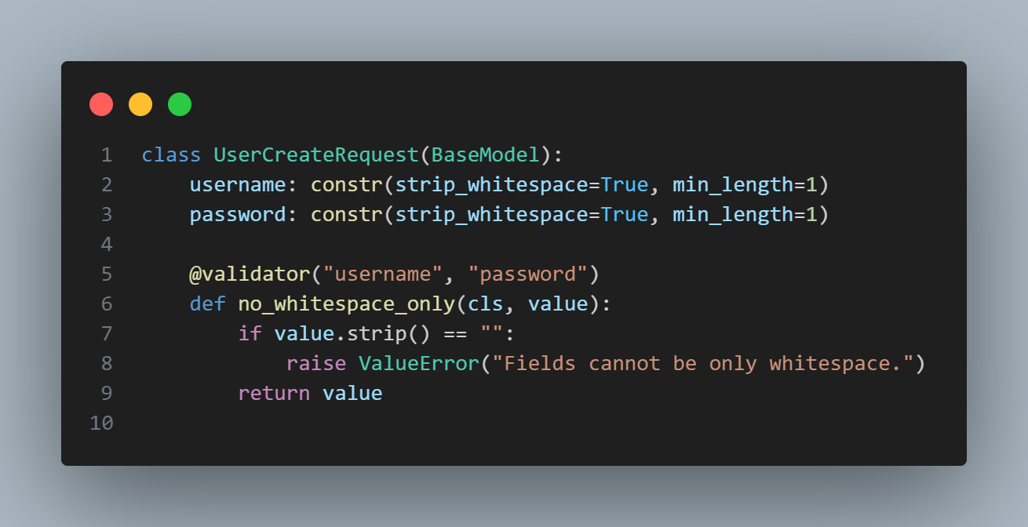
Figure 15
- username: Validates that the username is not empty and is at least 1 character long.
- password: Validates that the password is not empty and is at least 1 character long.
- no_whitespace_only: A validator that ensures no field is filled with just whitespace.

- PasswordRequest Class (Pydantic)
This class is used for validating the password data when storing or deleting passwords associated with a user. It validates the website, site username, and password fields.
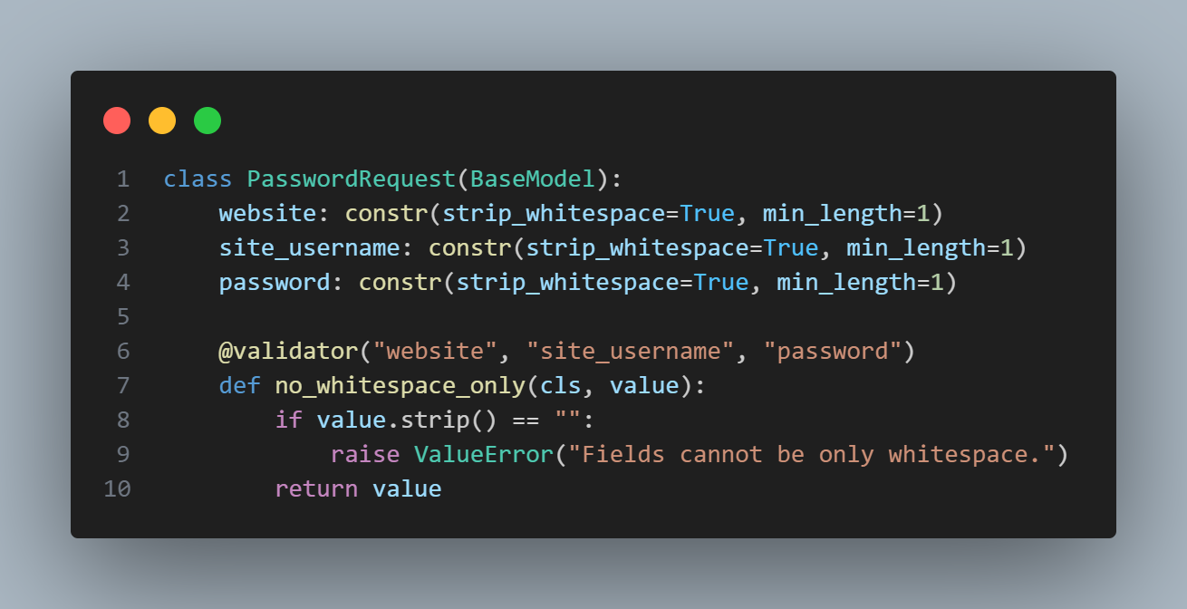
Figure 16

- website: Validates that the website is not empty and is at least 1 character long.
- site_username: Validates that the site username is not empty and is at least 1 character long.
- password: Validates that the password is not empty and is at least 1 character long.
- no_whitespace_only: A validator that ensures no field is filled with just whitespace.
- password: Validates that the password is not empty and is at least 1 character long.
- no_whitespace_only: A validator that ensures no field is filled with just whitespace.
Database Relationships and Structure:
- User and StoredPassword: Users store passwords for various websites or services, which are recorded in the StoredPassword table.
- UserPassword: The UserPassword table connects User and StoredPassword tables, allowing users to store multiple passwords. Each password is associated with a website, site username, and the actual password (encrypted).

Relationships Summary:
- One-to-many relationship between User and UserPassword: A user can have many stored passwords.
- Many-to-one relationship between UserPassword and User: Each password entry is tied to a specific user.
- One-to-many relationship between StoredPassword and UserPassword: A stored password can be linked to many users (e.g., sharing the same password between multiple users).
- Many-to-one relationship between UserPassword and StoredPassword: Each UserPassword is linked to a particular stored password entry.
These relationships allow for flexibility in storing multiple passwords per user, encrypting passwords for security, and maintaining organized data for each user and their stored credentials.

APPENDIX ONE(1) - Test Cases

Below are the test cases used to validate functionality and robustness:
Unit Test 1 |  | Test Class: UserRegistration | Designed By: Charan Basava
Data Source: User Entry |  | Objective: Register user with  valid credentials | Tester: Charan Basava
Test Case | Description | Tasks | Expected Result | Actual Result
1.1 | Test for user  Registration | Enter New User Details:  Username: user1,  Password: test12345 | “User created successfully”,  with username | Passed

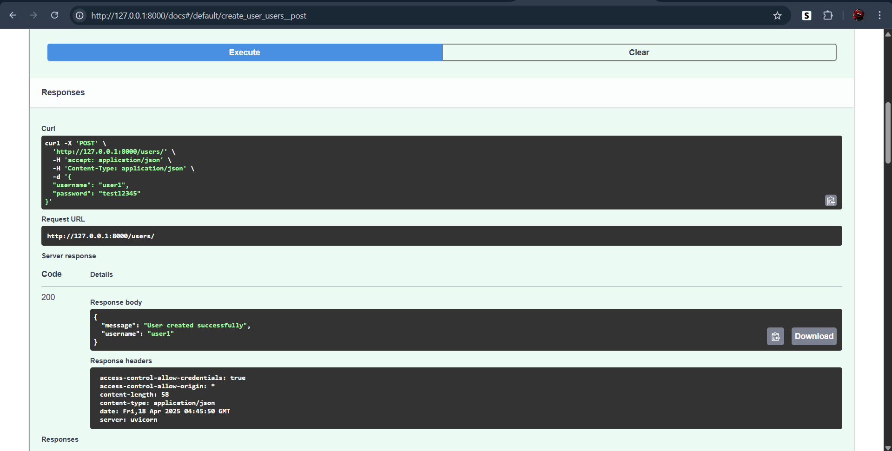
Figure 17

Unit Test 2 |  | Test Class: UserRegistration | Designed By: Charan Basava
Data Source: User Entry |  | Objective: Register duplicate  user | Tester: Charan Basava
Test Case | Description | Tasks | Expected Result | Actual Result
1.2 | Register duplicate user | Attempt to register a user with an existing username  Username: user1,  Password: test12345 | 400 Bad  Request, “Username already taken” | Passed

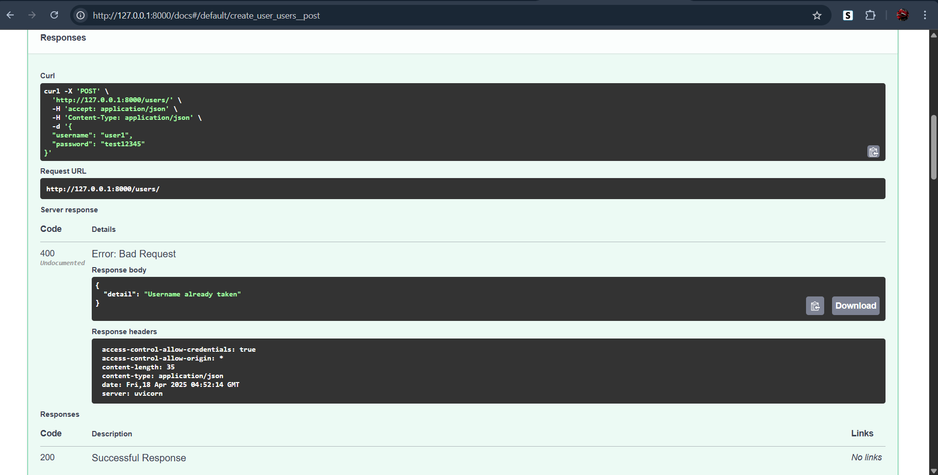
Figure 18

Unit Test 3 |  | Test Class: UserLogin | Designed By: Charan Basava
Data Source: User Entry |  | Objective: Login with valid  credentials | Tester: Charan Basava
Test Case | Description | Tasks | Expected Result | Actual Result
1.3 | Login with  valid credentials | Enter valid credentials:  Username: user1,  Password: test12345 | 200 OK with  “Login successful” and username | Passed

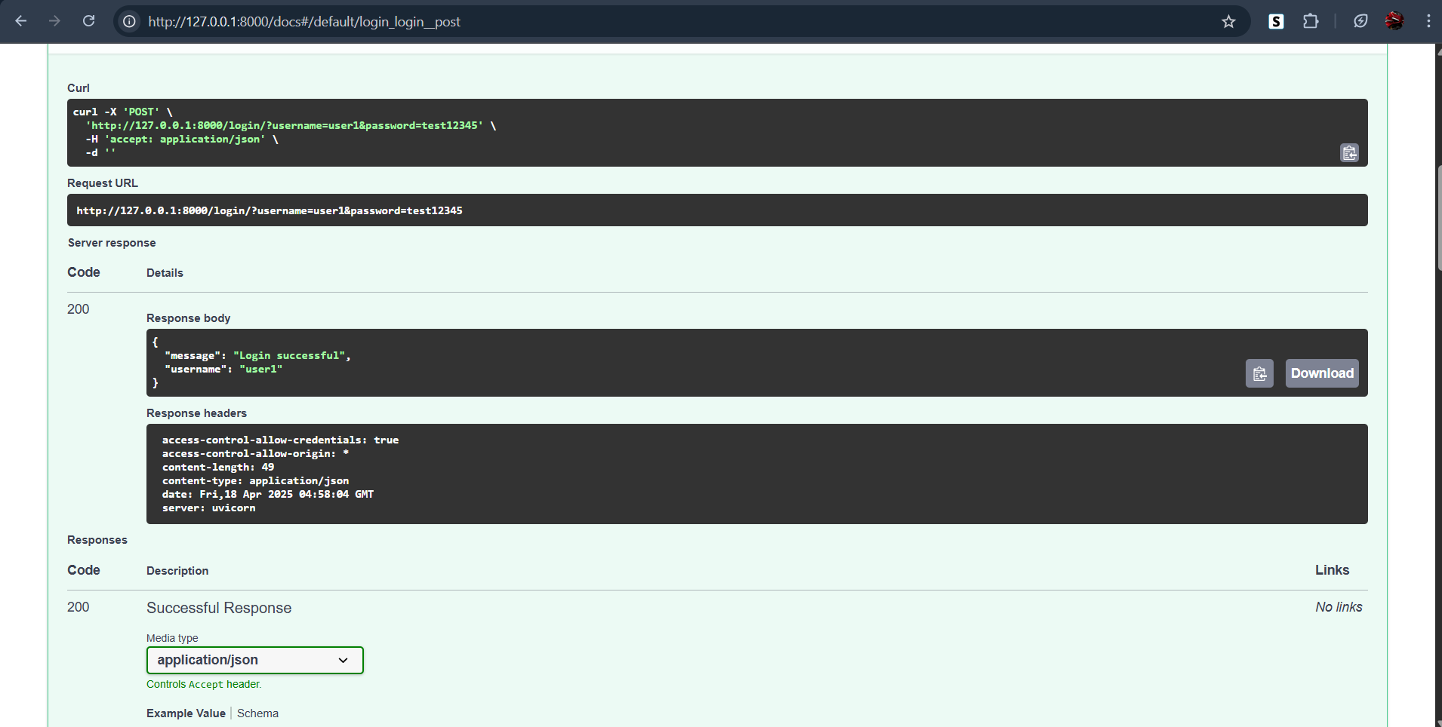
Figure 19

Unit Test 4 |  | Test Class: UserLogin | Designed By: Charan Basava
Data Source: User Entry |  | Objective: Login with wrong  password | Tester: Charan Basava
Test Case | Description | Tasks | Expected Result | Actual Result
1.4 | Login with  wrong password | Enter invalid password for  existing username  Username: user1,  Password: wrongpass | “Invalid username or  password” | Passed

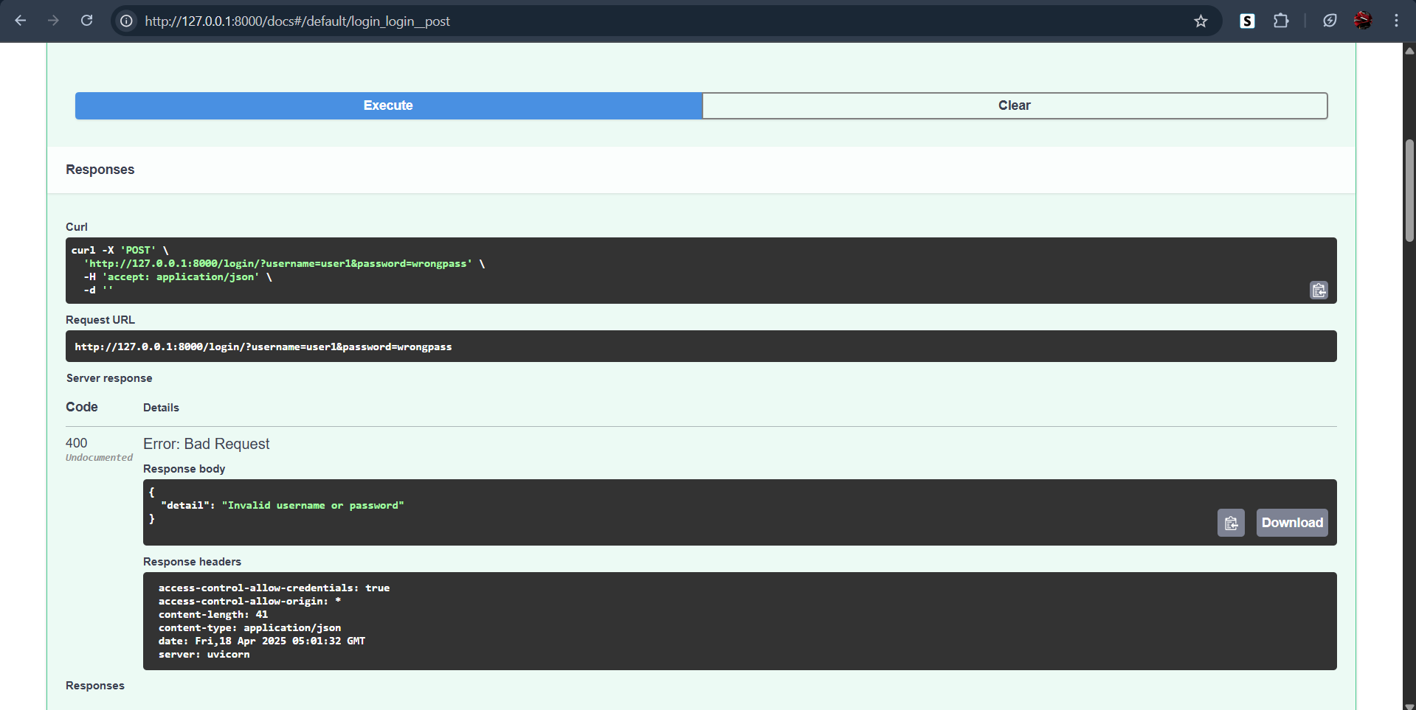
Figure 20

Unit Test 5 |  | Test Class:  PasswordManagement | Designed By: Charan Basava
Data Source: User Entry |  | Objective: Store password  with all fields valid | Tester: Charan Basava
Test Case | Description | Tasks | Expected Result | Actual Result
1.5 | Store password with all fields  valid | Store a valid password for a  User  Service: Gmail, User: user1,  Password: xyz | 200 OK  “Passwords stored successfully” | Passed

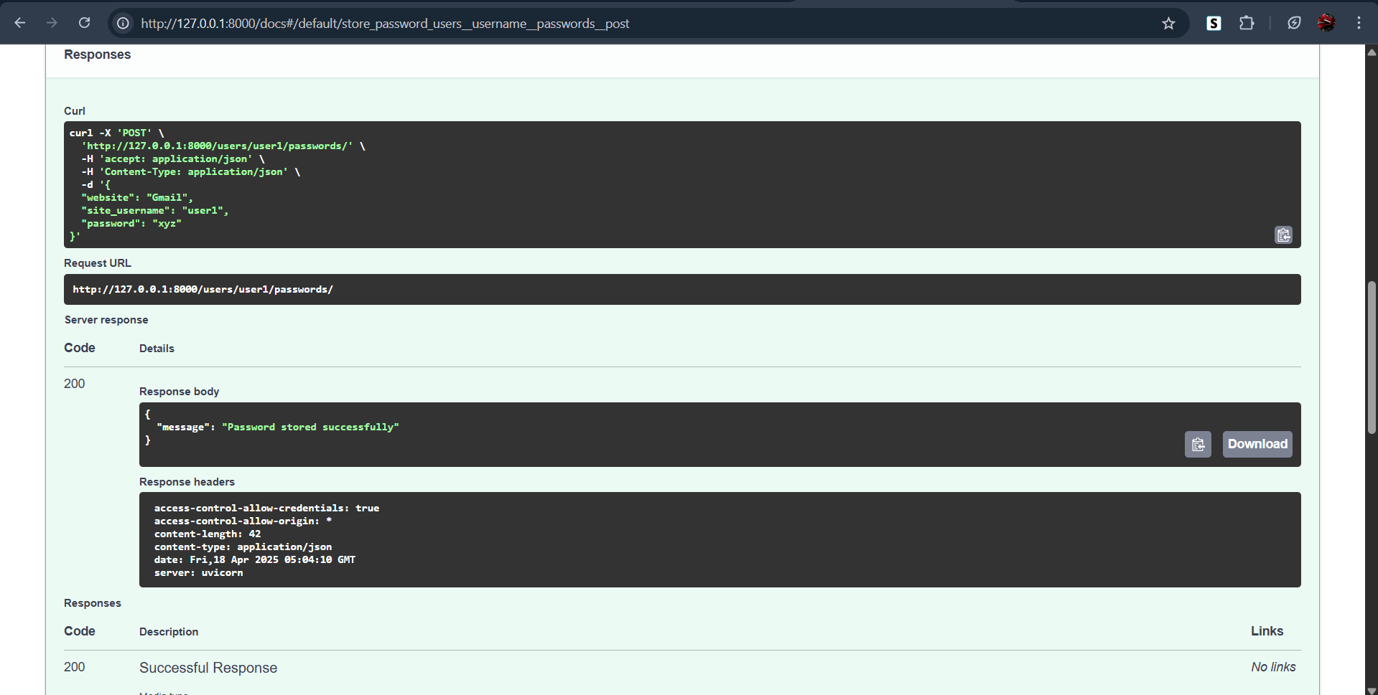
Figure 21

Unit Test 6 |  | Test Class:  PasswordRetrieval | Designed By: Charan Basava
Data Source: User Entry |  | Objective: Retrieve stored  passwords | Tester: Charan Basava
Test Case | Description | Tasks | Expected Result | Actual Result
1.6 | Retrieve stored passwords | Retrieve saved passwords for user1  Username: user1 | Decrypted list of services  and passwords | Passed

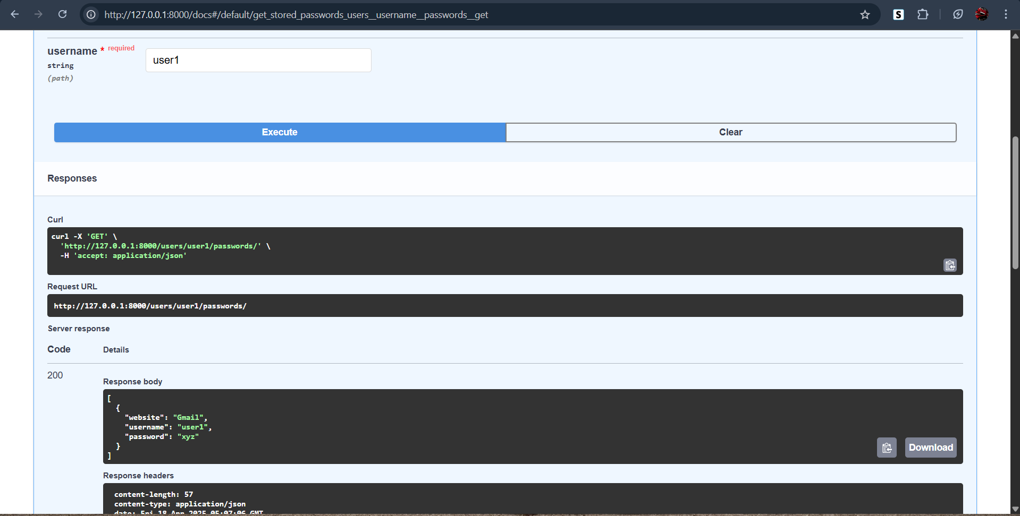
Figure 22

Unit Test 7 |  | Test Class: DataSecurity | Designed By: Charan Basava
Data Source: MySQL  Database Query |  | Objective: Verify encryption of stored passwords | Tester: Charan Basava
Test Case | Description | Tasks | Expected Result | Actual Result
1.7 | Verify encryption of  stored passwords (Internal Test) | Query MySQL database to  confirm passwords are not in  plaintext | Password field contains  encrypted strings | Passed

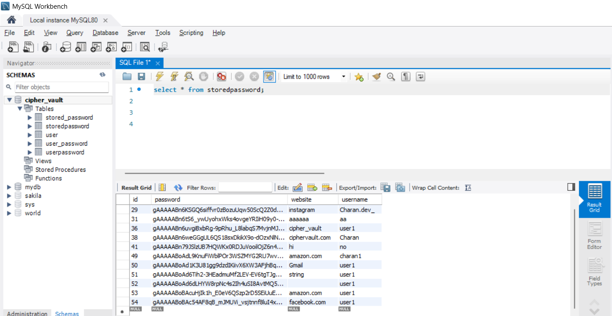
Figure 23

CipherVault User Guide
1. Introduction
CipherVault is a secure, lightweight password manager designed to help users store, retrieve, and manage passwords for their various accounts in a safe and user-friendly way. This guide explains how to register, log in, store passwords, and access saved credentials.

2. System Requirements
- Operating System: Windows, macOS, or Linux
- Browser: Chrome, Firefox, Edge (latest versions)
3. Accessing CipherVault
- Open your browser.
- Navigate to the CipherVault homepage.
- You’ll be presented with options to Sign Up or Log In.

4. Registering an Account
- Click Sign Up.
- Fill in the following:
  - Username
  - Password (at least 12 characters, letters and numbers only)
- Click Register.
- You’ll be redirected to the login page upon successful registration.

5. Logging In
- Enter your username and password.
- Click Login.
- If correct, you'll be taken to your Dashboard.

6. Dashboard Overview
The Dashboard gives you access to the Navigation center which should have
- Passwords (which should drop down “Encrypt and store” and “Check Strength” when hovered upon)

7. Storing a Password
- Inside the Encrypt and Store page, click Add Password.
- Fill in:
  - Service Name (e.g., Gmail)
  - Username or Email
  - Password
- Click Save.
- The password is encrypted and saved in your secure vault.

8. Viewing Saved Passwords
- Click View Passwords.
- You’ll see a list of saved services and usernames.
- Click Reveal next to an entry to view the password (you may need to re-enter your master password for security).

9. Deleting a Password
- Go to View Passwords.
- Click Delete next to the entry you wish to remove.
- Confirm deletion.

10. Logging Out
Click Logout from any page to securely exit your session.

11. Security Tips
- Choose a strong, memorable master password.
- Log out after each session, especially on shared devices.
- Never share your account credentials.
- Use CipherVault only on trusted devices.

12. Getting Help
If you encounter any issues or have questions, contact the support team via email: Charanbassva.bb@gmail.com.

System Code
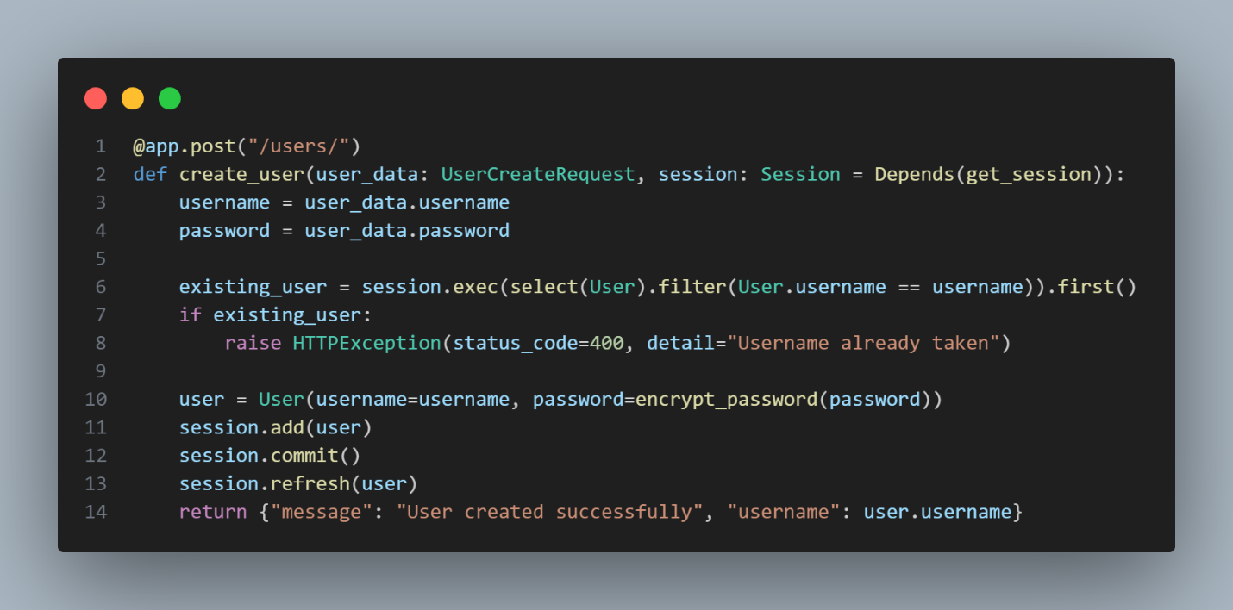
Figure 24
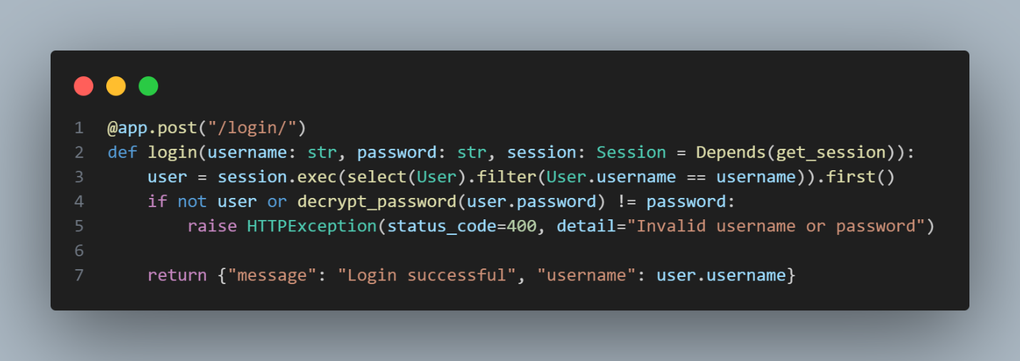
Figure 24

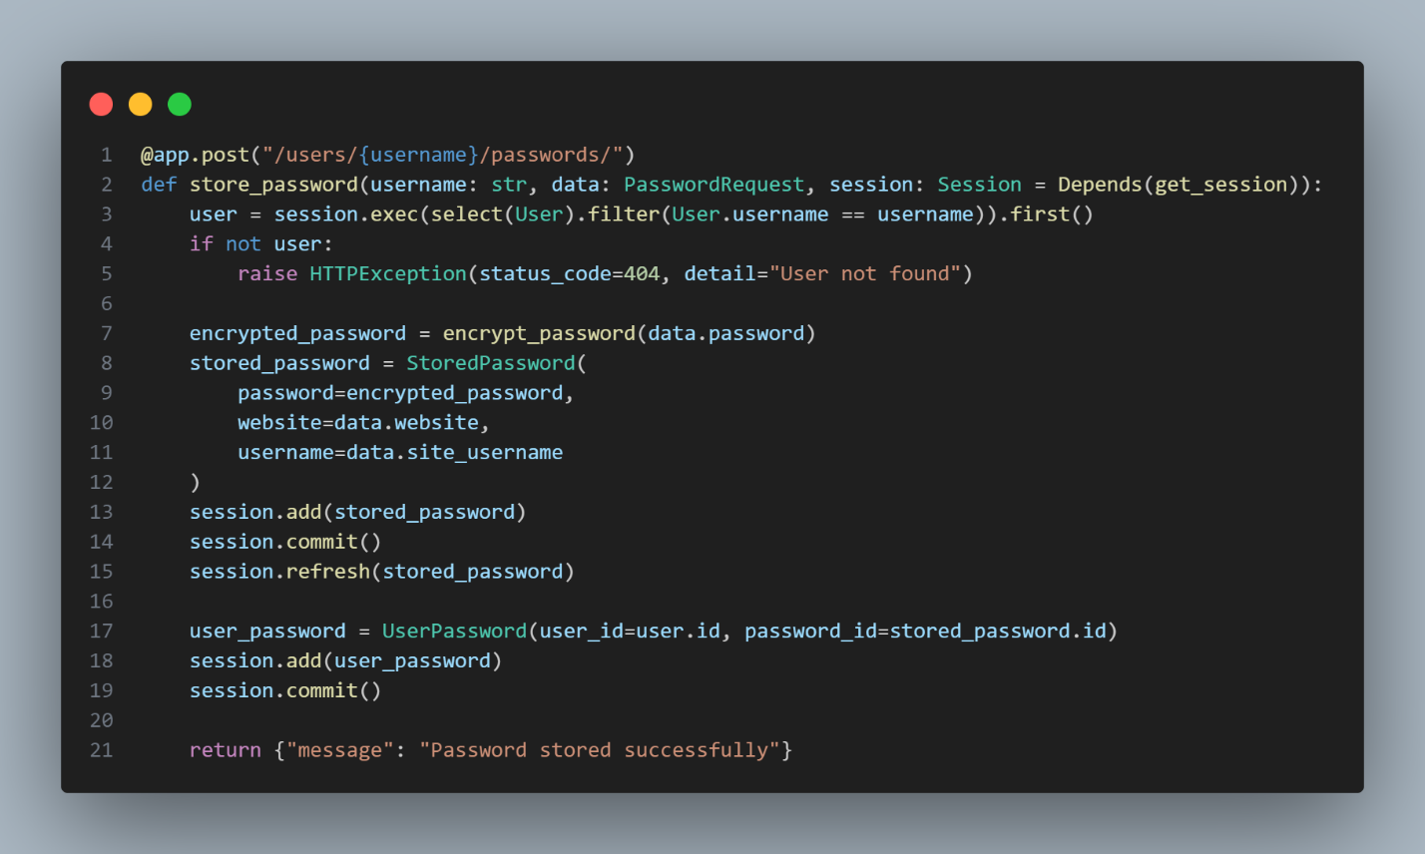
Figure 25

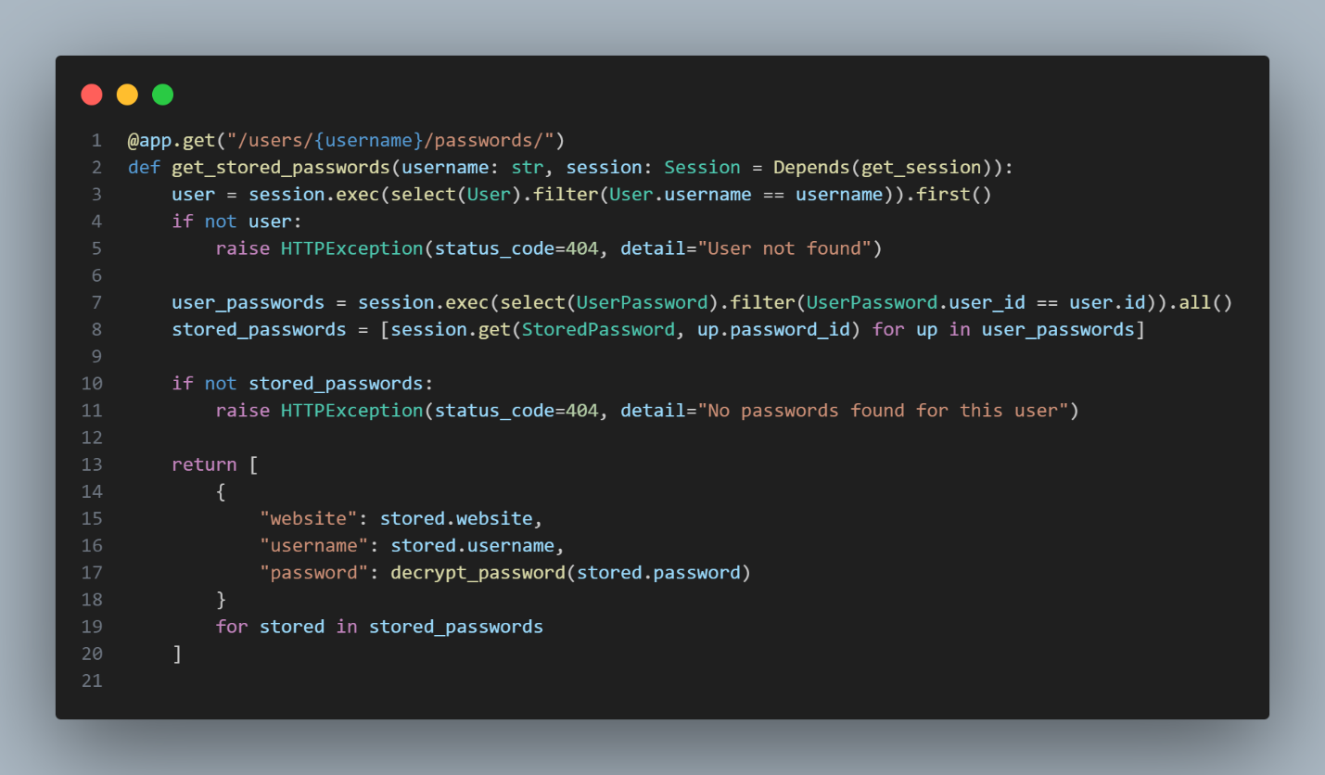
Figure 26

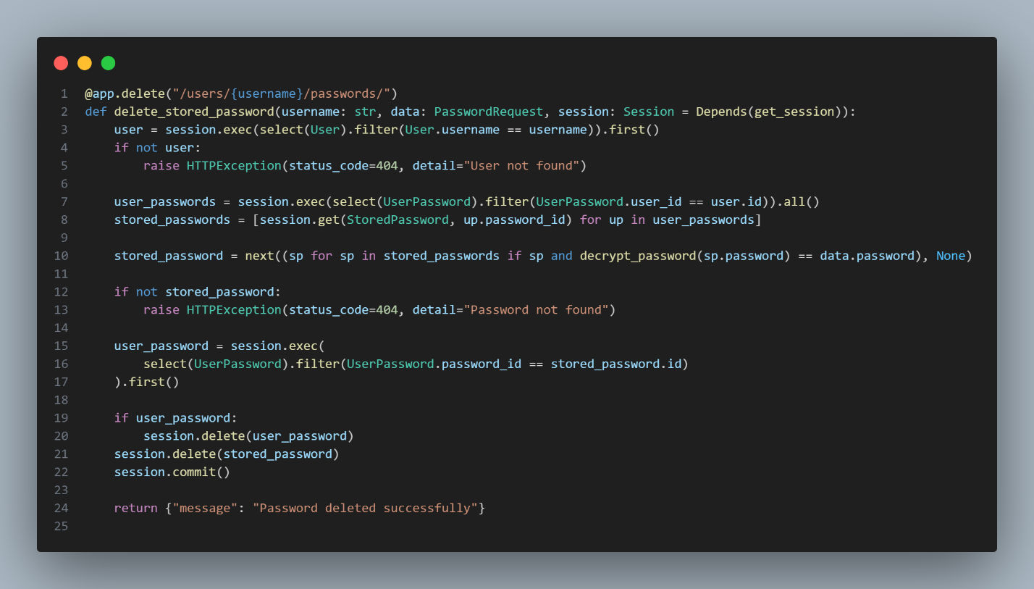
Figure 27

6209 words__

